**Bachelor of Science in Electronic Engineering**

Laboratory Activity No.1 (**Using If Statements, Integer & Double Data Types, and Scanner**)

**Passed by**: Santiago Rafael D. Manalang(883969)

**Instructor**: Engr. Jamie Eduardo Rosal,MSCpE

**Date Passed**: August 20, 2025

Test Run #1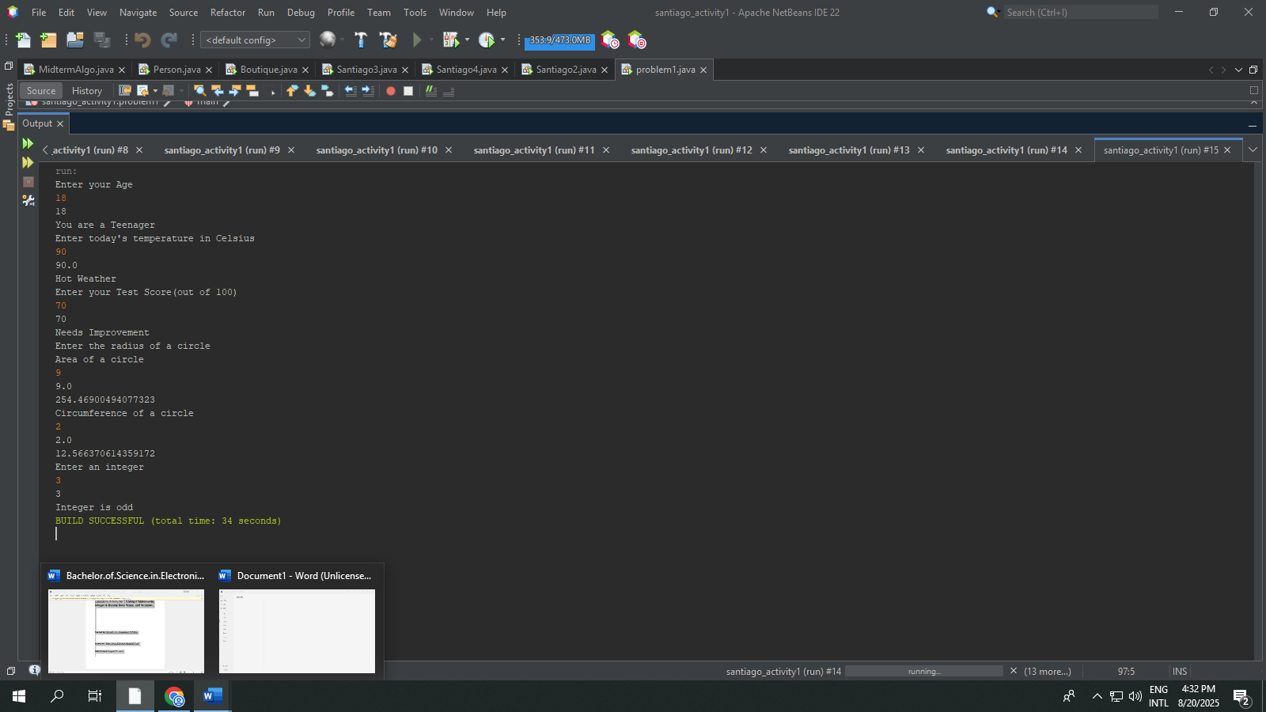

Test Run #2

